**Cosmos**

*Where we came from*

*Why we are here.*

Mike Croteau

Have a look at the following images and ask the question, “Does evolution really exist”.

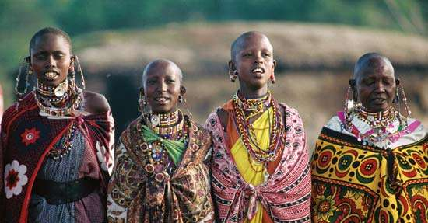Africa

India

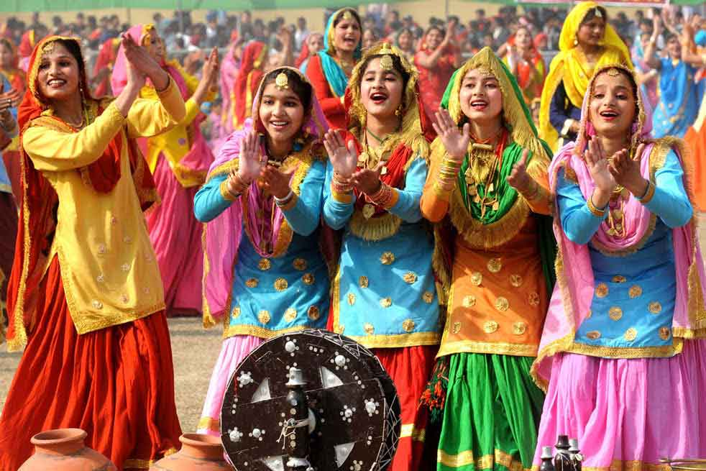

Germany



Saudi Arabia

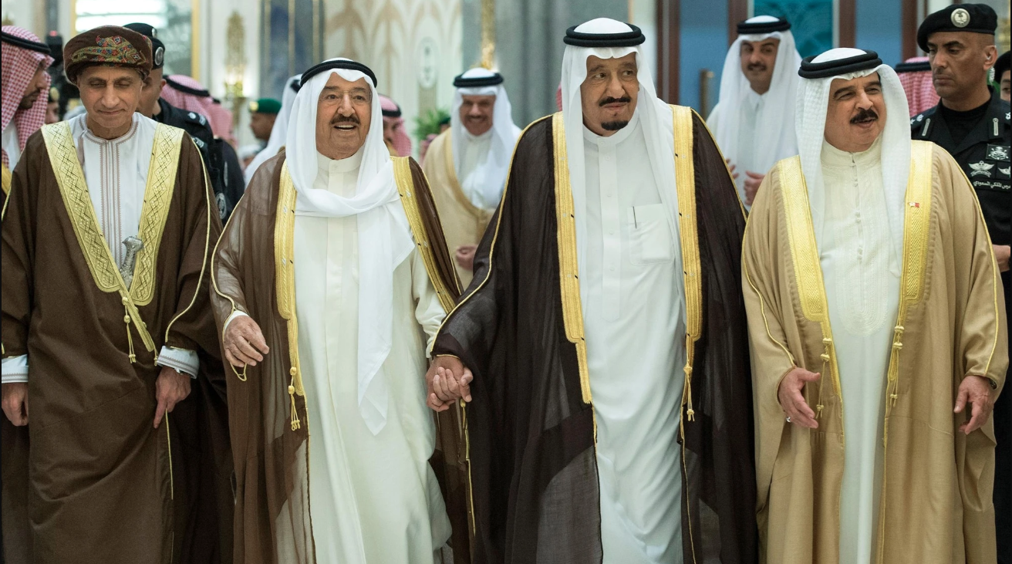

Russia



China



Mexico

Brazil



So what did you see? Did you see Evolution or Original Design? It is plain as day, if not, hopefully by the end of this book it will be, each group of people was created. It goes against what we are taught, yes I understand, but bare with me. I hope you enjoy the book.

First off, thank you for picking up this book. It is short and to the point. Depending on your background, this book could change the way you look at your life, your belief system and your entire way of living, in addition where we came from and our purpose moving forward. The content of this book can be a little much to take in at first and may seem outlandish. That is ok.

In order for you to reach the same conclusions you are going to have to suspend your disbelief for the entirety of this book. If you don’t what that means, it means you have to throw out any preconceived notions about your life and what you know to be true, everything regarding your existence, your purpose and life in it’s entirety, how we came to be and even God, everything. Start from scratch, a clean slate of mind, a clean slate of a supporting belief system. Don’t hold onto anything.

What do I hope to happen from this book without upsetting people. I hope more people believe in God.

Everything in this book excluding our purpose is original thought. Years ago I separated myself completely from what I knew to be true and what was comfortable and immersed myself completely into thought. I separated myself from everything, text books, tv, religion, people and just focused on the questions at hand comparing observing human beings, comparing images of different nationalities, organizations of people, animal life and plant life in order to travel to new lands of thought to come to the conclusion that we were created by life outside of. Earth, **Cosmos** and that there is more than one group or classification of human being on Earth.

So lets begin...

During our lives we are taught how to think, how to reason, what to believe in and even how to pray. Because our lives are so busy, 99% of us don’t have time to think about life’s grandest and most outstanding questions, especially outside of our social norms, structures and our routines. However, I am willing to bet, if you sat down, and did the same, separated yourself from what you know now as the truth and thought about everything, the Earth, the stars, the Universe, people and animal life, you may come to the same conclusions. You first need to look at the stars, look to the Galaxy, look to the Universe, look to people and ask how? (If you think too much about the World, you may lose out and only think in terms of Jesus, Muhammad or Buddha. If you think about Galaxies, something different will happen.)

I believe we have the answer to life’s questions, where we came from and why we are here, Ill cut to the chase, the answer we were created by something, something much grander than us, something where many were involved. Something unique, and something grand, **Cosmos**, what is Cosmos defined in this book? Cosmos is defined is life outside of Earth, **extraterrestrial life**, yep, **Extraterrestrials**, and our purpose is just as grand, unique, meaningful and challenging… to create **Utopia**.

By now you may be ready to put this book down and move on with your life, I urge you not to. Give this book a serious try, please. I could use your help, I don’t know where to go myself from here knowing what I know or thinking how I think, you could possibly help me and other people.

You may also be asking yourself how I came to this conclusion. Again, I separated myself from my current life, pretended everything was new, took in imagery, took in a lot of information, had a lot of original thought and it became difficult, very difficult, but here I am now reaching out to you with my new found knowledge with the hope of reaching you, hopefully allowing to think independently without fear or guilt.

Here are the two problems we face while thinking differently. First, time is an issue, this book is short and gives you a jump start in pondering life’s greatest and most outstanding questions. The other issue lies with your pre-existing belief system. If you are someone who is devout, and is surrounded by many who are the same, and these thoughts don’t align, it will be difficult to shake your pre-existing ways out of fear, guilt and for some stubbornness. “We could face social scrutiny if we think on our own and go against our current belief system.” With these issues in mind, please come with me and separate yourself completely and dive further into this book.

First lets talk about God. Some of you may not believe in God and instead in the “Big Bang” theory. Some of you will say, God exists and we were created by him, that all of Earth, animal life, and the entire human race originated from him. Some will say its a her, you’re prob. The image of God can also differ. Some people will reference the Bible, Jesus, Adam and Eve and Noah’s arch, etc. Others will say the same, “We were created by a singular God”, except instead of referencing Jesus or any other religious figure will use intelligent design as to answer the grand question of “how”. If you are not familiar with Intelligent design, Intelligent Design is the idea that a single celled organism originated all of plant, animal and human life.

Then there are Buddhists, Muslims, Sikhs people that follow Confucius and those that are Deists (My favorite religion of them all).

The last group of people are people who are more aligned with no belief at all, Atheists and may believe in the big bang theory, that everything that we see today including ourselves started from an explosion which began the creation of all life as we know it on Earth, and that the Universe is ever expanding. These people also may believe that everything again including us originated from a singled celled organism.

All options are a good and can be seen as reasonable, however I believe all are not the truth. The evidence is really clear once you stop, think, compare and think again, and reason and think again and think some more, think about everything, and once I present some imagery things should come into shape a little more.

This is a short read, so please avoid all temptation to throw the book down. Again, separate yourself from everything that you know, everything, especially your religious ties, your social structures and really try to critically think observing the differences in the imagery that is displayed. Remove fear as well if you have any, God would want you to seek fully first not accept what was handed to you. I believe God exists and wants us to have a more intimate relationship with him. Give this your full attention, you will only benefit if you are honest with yourself. Your whole being, existence, and beliefs may change after taking this book in. It may definitely change after understanding this one fact… You were created by Cosmos, what I also refer to as Beautiful Life, life outside of Earth, also known as Extraterrestrials. I’ll use Cosmos loosely, but they mean life outside of Earth, and God created us all.

By the way if you are still with me, fantastic. It’s a wonderful World and we have meaning and a purpose but it’s going to take a general consensus. Read everything, view the imagery and think, again really think and try to understand how we came to be. Our shape, our design, our being, everything about us is nothing next to a miracle. Again, it’s plain as day once it sets in.

Look at the World as a whole. There are people out there that are teaching migration patterns, the human genome project combined with evolution. There is probably **some** proof of evolution but not to the extent to which we are being led to believe today. We did not evolve from a single-celled organism. The human race is composed of many organizations of people, and each were created. We call them nationalities and races, we are all very much compartmentalized in our nature, each culture is a nationality. Every group of people is very different. So different that with some thought, each group could be seen as being created independently and that evolution can easily be seen as bogus. It’s a reality. If you don’t see it at first, it’s ok. Let’s look at a few of these groups, organizations, nationalities of people and try to think about how they came to be.

China

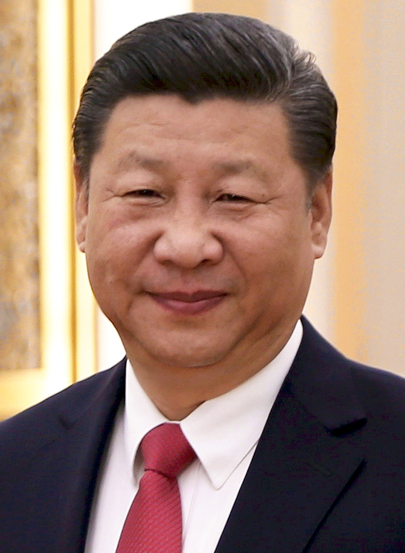

Look at this gentleman from the Republic of China. Lets look at their features, their eyes, their ears, their skin color, every aspect needs to be taken in, observed and considered. How slender of a build they present, how light their skin color is, how pronounced their eyes are, their height, their build, their language, their customs, their culture, their food, their religions very much different from any other group, nationality of people in this World.

Taking evolution into consideration, we need to first examine where it is said the first human originated. It is believed that we all originated from the same region of the Earth, Africa. So in order to fully review and observe evolution we need to compare just about everyone on Earth to our originating source, Africa. The images may be humorous at first glance, but are important, they should show traits of evolution right?

Let’s do this exercise first with the People’s Republic of China. The differences between someone from modern day People’s Republic of China from someone from Africa are vast. There is no evidence of evolution between these two groups of people. Take a look for yourself and ask questions of “How”.

|  |  |
| --- | --- |
|  |  |

Where is the evolutionary chain?

Observe the differences in the eyes, ears, nose, shape of their heads, shape of their torsos, skin tone, the differences are immense. What external factors if any would shape man into a modern day person from the People’s Republic of China if we all originated from Africa?

External factors like weather, diet, atmosphere or anything tangible needs to be taken into consideration when thinking of evolution, and if you do, you will notice that none of the above factors could bring a person from an African decent to a modern day person from The People’s Republic of China. There are similarities but the differences are so pronounced that evolution is not the answer, it is not the truth, and if we do the same for all groups of people on Earth (excluding North America).

We can compare someone from Russia to our originating continent Africa.

|  |  |
| --- | --- |
|  |  |

Again, taking a gander at the two images side by side, for just a second may make you chuckle. What external factors would shape a man into a person from modern day Russia? Again, where is the evolutionary chain? It does not exist. Both were created independently, each had it’s own **Architect**.

Why don’t we compare two neighboring nations that share similar climates taking weather into consideration as an evolutionary variable. Let’s observe someone from the Peoples Republic of China to someone from Russia.

|  |  |
| --- | --- |
|  |  |

The regions in which these two organizations of people are nearby and share similar climate but the differences between the two cultures are enormous, everything about each culture of people are different, the people, the food, the approach to life and their languages are very much different. No weather pattern, vegetation, plant life, animal life, or diet developed a person from from China to a person from now Russia or vice versa.

Why don’t we look at a person from Iraq compared to a person from Russia and see if we can spot evolution, remember, that is the goal.

|  |  |
| --- | --- |
|  |  |

The same, there is no evidence of evolution!

Again, how about the handful of wonderful nations?

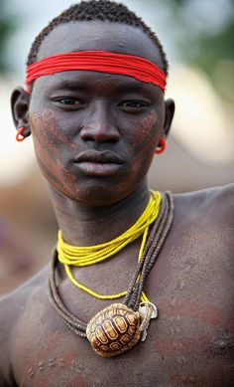

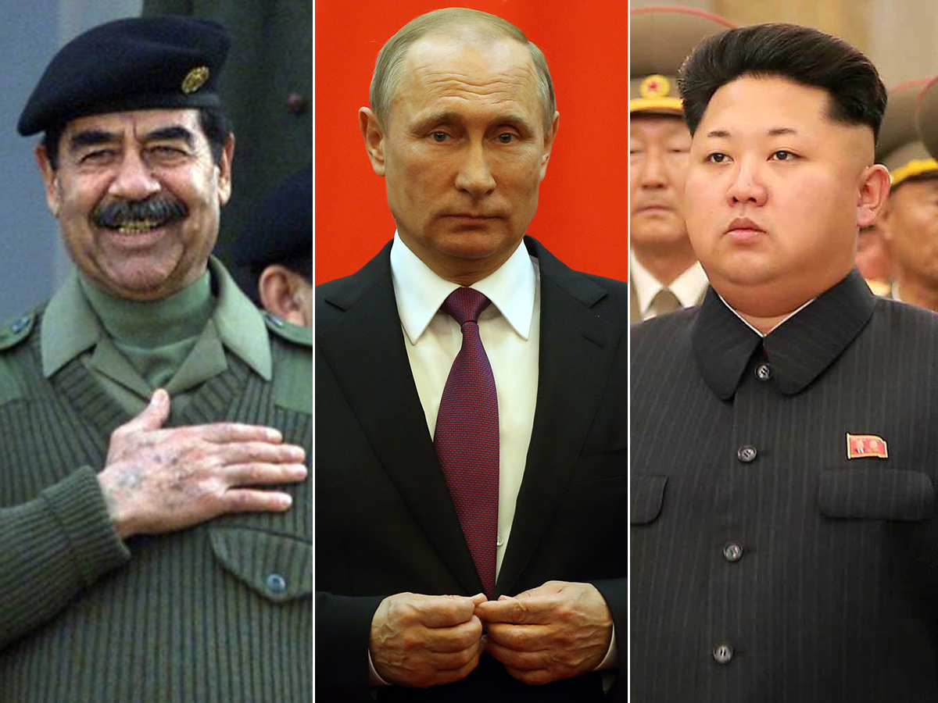

Each group of people has its own **Architect!**

Look at the images, observe the differences in each group. The differences are pretty obvious aren’t they? It should have hit you already a long time ago, but the crux of it is we did not evolve, each group of people was created independently. Each group of people is very much different, each group originated by Cosmos.

Every one of these groups are so different, if you really view them and see the differences, you may start to think how they did come to be. Each group was created individually and placed in their own neat compartment on Earth. No evolution, none at all. It does not exist between them, evolution does not exist in the human race (and doesn’t exist very much elsewhere either).

The similarities between all the groups of people on Earth form what we can think of as a base, or what we can refer to as a template of a human being, a base template, two eyes, two ears, a nose, two legs, two arms, five fingers and five toes, a beating heart and a working mind. But other than that, each group of people are original in their appearance and their way of life. They are each their own way and kind, they are visibly seen as “**Original Designs**”. No evolution. There is no evidence of evolution in any of the images presented. One group is not more mature in age of existence than the other.

Here is the theory that I came up with, a theory that I believe is the answer, it makes the most sense but you will have to suspend your disbelief. **I believe there to be a hierarchy outside of Earth that originated us**. A being that maintained a template, a template of a human being which over time was refined into what is now known as a modern day human being. I believe this group of beings, **Cosmos**, **each was instructed to go out and create what they individually believed to be the most beautiful, loving, caring, attractive, intelligent, hard working, industrious, energetic, engaging human being and some even were given a plot of land on Earth to work with**. **I believe this group, what I refer to as the Cosmos went out and each whittled together what they believed to be the most perfect human being, they did this along with our cultures, our languages and our social norms.**

I believe this to have happened for most of all organizations of people that currently exist on Earth. I believe that the Cosmos did this for all “**Original Designs**”.

After each member of Cosmos completed their task and completed what they thought to be a perfect human being along with their supporting language, they then turned their work into their instructor… their overseer, our overseer, the one that overlooks us all … …

There is proof in comparisons of groups of people, languages and cultures. Let’s look quickly at languages. When you look at these languages I want you to ask yourself, “how did these come to be?” and no kidding, “did a human being conceive of these?”. “And how on Earth did this language become?”. “Did languages evolve? If so, can I spot evolution or are they all different in their own way?”. Here is “**Hello, how are you?**” in a few different languages.

**Arabic** - The most sexy and persuasive language

مرحبا كيف حالك

**Russian** - The most structured and disciplined language.

Привет как дела

**Hebrew** - One of my favorites. Modern, love powerful.

שלום מה שלומך

**German** - A very strong language.

“Hallo wie geht's dir?”

Lets compare two somewhat neighboring languages, Hebrew and Arabic

|  |  |
| --- | --- |
| שלום מה שלומך | مرحبا كيف حالك |

How similar are the two languages? If evolution were true wouldn’t we see gradual changes in culture and language instead of abrupt and obvious differences?

Each of these languages resemble something creative beautiful mind to constructed. If you don’t believe that life outside of Earth created us, and most of our supporting languages, go ahead and try to conceive of creating an alphabet yourself. Go ahead, create a new alphabet, a new vowel, a new word, a new language. It could be beyond our capabilities. **They, Cosmos, our Architects** set out to create what they believe to be the most beautiful, creative languages to support the culture in which they exist in. I believe that Cosmos helped created these beautiful languages. I believe this to be the truth. (By the way, if this is the case, the individual responsible for Sinhala is enormously creative and interplanetary).

Ever notice how each culture in this World is so different? Have you ever asked why? Why is the food different in India where curries and spices are heavily used compared to other areas of the World? How about their customs, religions, social norms. All are very very different. If you spend time in any other country outside of your home country, somewhere where the written and verbal language is different, it is truly like traveling to a n entire new World. A World within a World. Each culture is very much different, why, because of **Cosmos**.

If you believe in God, I love you. If you believe in Jesus, I understand. If you believe in Muhammad, outstanding. If you believe in anything that protects good people while helping others to become better people, I think nothing but the best of you. However, I do think it could be time to review what is our foundation and what is important in life and what we now know as the truth and base it on modern day knowledge. I believe everything I stated to be the truth, and this may sound crazy to some, but modern day religion may need to be refactored. Stories and ideas that date back more than 2000 years ago do not really align with or help us in the modern day World. I believe it is time to revisit the bible, revisit all faith based organizations and refactor what we believe to include what we now know regarding how the World works. If you are at the top of some of these faith based religions and believe this to be blasphemy, you only seek to control not good. Better, I believe that a new faith based group could be formed, a group that follows the basic foundations of life and how the Universe works. I believe this could include Quantum Mechanics, Quantum Physics and basic understanding of human needs and laws.

Some will say there is no way that life outside of Earth, Cosmos created us rather again a single God created us. Really view the World, there is way too much going on here to believe this to be true. **There are too many distinct differences in cultures, people, animal and plant life for a singular creator. If singular God designed and created us all, we I believe we would all be much very much similar in every which way possible, appearances, cultures, food, languages and belief systems.**

Just so you know, in addition to **Cosmos**, I do believe there to be a God. I believe he exists and wants the best for each one of us. If you do not believe in God, do this one simple exercise for me. It is simple. Ask yourself these two questions: “Do I feel bad when I do something I that know to be bad?”, “Do I feel good when I do something that I know to be good?”. Where do these feelings come from? These feelings, these instincts, these internal dialogs are real. I believe these feelings are God within each one of us. God attempting to navigate us into better parts of life and this World, to become better fathers, mothers, children, friends and overall people. If you are an Atheist, you could be scratching your head by now, you also might think of something pretty interesting, that maybe we are part of an actual logical program, a program that consists of binary yes and no data points and that there is a God algorithm to guide as all. We are not part of a computer program although alternates exist, we are living a reality disconnected from anything algorithmic. We are life harnessed into life, it is a miracle to conceive of creating life. It is as simple as that. The feelings of good and bad are again in fact God, speaking to you, reaching out to you, letting you know that he is watching, hoping, and rooting for you to make the right decisions in order for you to become what he expects as the very best version of yourself. He is love, it is love, we are love. God is within, and throughout this World.

There are people currently searching for God. There are scientists in Switzerland at CERN, the European Organization for Nuclear Research, one of the World’s most respected research organization dedicated to scientific research, and they are currently searching for God, what they call the Higgs Boson particle otherwise known as the “God Particle”. This belief that God exists everywhere including in everyone is not only a belief of mine but others as well. We will never find him or the Higgs Boson.

It’s important that you understand that I am not against faith based religions. I am hoping that with this information and these ideas that you will think independently about the World differently. In addition, if you don’t mind, it may be time to challenge your current belief system, God would want you to question everything and seek, seek and seek some more until you find him.

Here is another fun exercise, I hope you get the same feeling and come to the same conclusion as I did while performing this exercise. I want you to take a look at your hand. Look at it from the side, started to wiggle your fingers and move your hand back and forth. Do this next to a plant. You may either say to yourself “Adam and Eve” or “Holy cow, its foreign, we are foreign?”. Give it a try.



It’s important that you perform this exercise next to or in front of a plant. This may reinforce the truth. Give it a try, spend at least a minute performing this exercise and clear your mind of everything. If hasn’t sunk in yet ask this question, “Do we belong? Is the human hand foreign, is the human existence foreign to Earth’s organics?” This action is what spurred my search and quest into life’s questions where we came from and why we are here. The hand is foreign, the human body is foreign, we all together everything human being is foreign. We did not grow or originate from Earth, and we did not originate from a single celled organism. **We were created, created by God, created by Cosmos.**

Let’s now look at animal life briefly and talk about evolution and creationism. I believe all animal life on Earth was also created. The goal similar to human life to create beautiful, balanced, sustainable environment on Earth. Taking a view at a few images of animal life can quickly force you to come to the same conclusion, that animal life was created as well, not originating from something other than its current form or a single celled organism. Again, in order for any of us or animal life to have originated from a single celled organism our structures would have to be a lot less defined, a lot less strong and structured, meaning our shape would have to be more malleable, shapeable, but we are not. We are very much definitive in our shape and structure. External factors are not going to reshape our being or our existence, it is important that you know this, we will adapt instead of evolve.

Let’s look at a few images of animal life. During this ask yourself “How did this animal come to be?”. It is an amazing experience observing and thinking. I hope you are able to do this free from your life backgrounds and pre-existing beliefs.

Giraffe

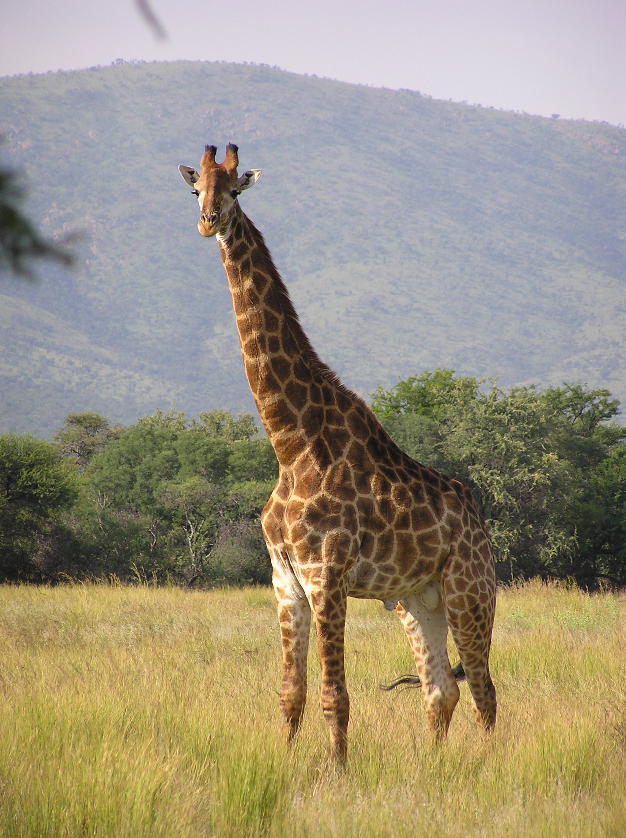

Where did this creature originate from? Look at its shape. What factors forced this animal to have a long neck and not other animals within the same animal kingdom and region where this Giraffe originates? What about it’s legs and the downward slope of its torso? Does it look as if it evolved or created. If it evolved than how? What is it’s base? What animal did it originate from? I asked someone these questions and a horse was their answer. This is not possible, the horse over time would not have survived the evolutionary chain, it would have died off in between somewhere. If you want to compare the horse in Africa, the Zebra, the Giraffe is very much an original design God created for us. (As you go through these next set of images, pause, really pause and disconnect from everything, pretend you are a kid again and you are figuring things out on your own instead of taught. Think, think, think. Be a kid again, enjoy thinking on your own independently, it’s freedom, it’s what we were born to do.)

How about the Siberian Tiger? Where did this creature originate? It does not fit. It was created.



The Shark:

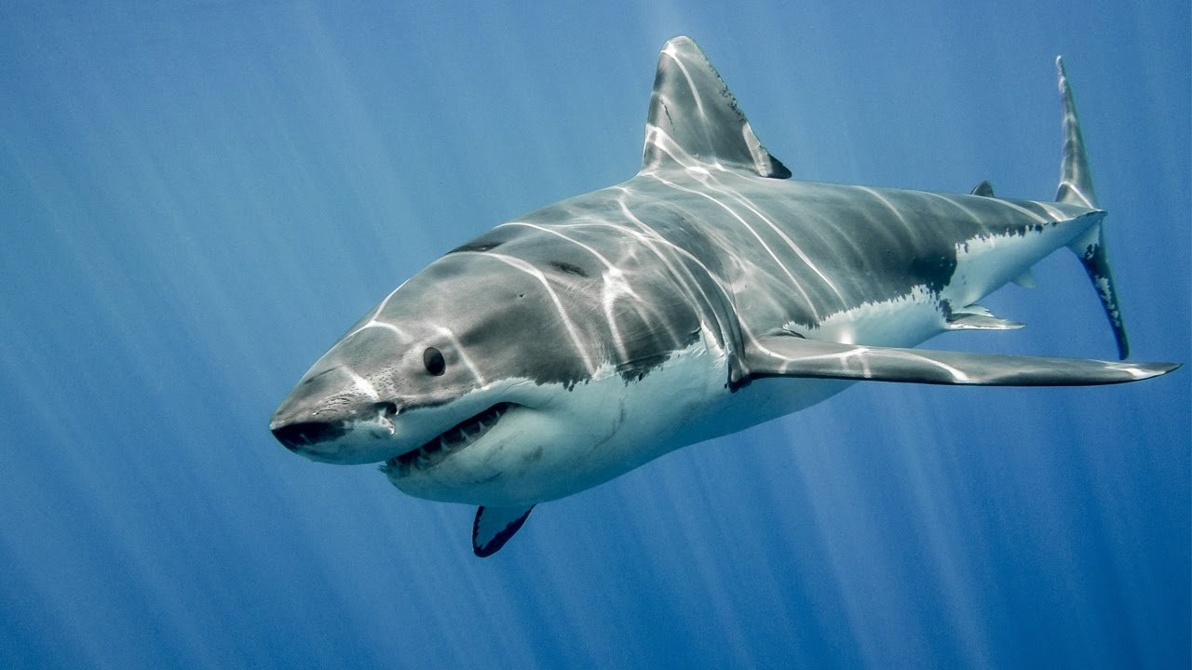

The crocodile:

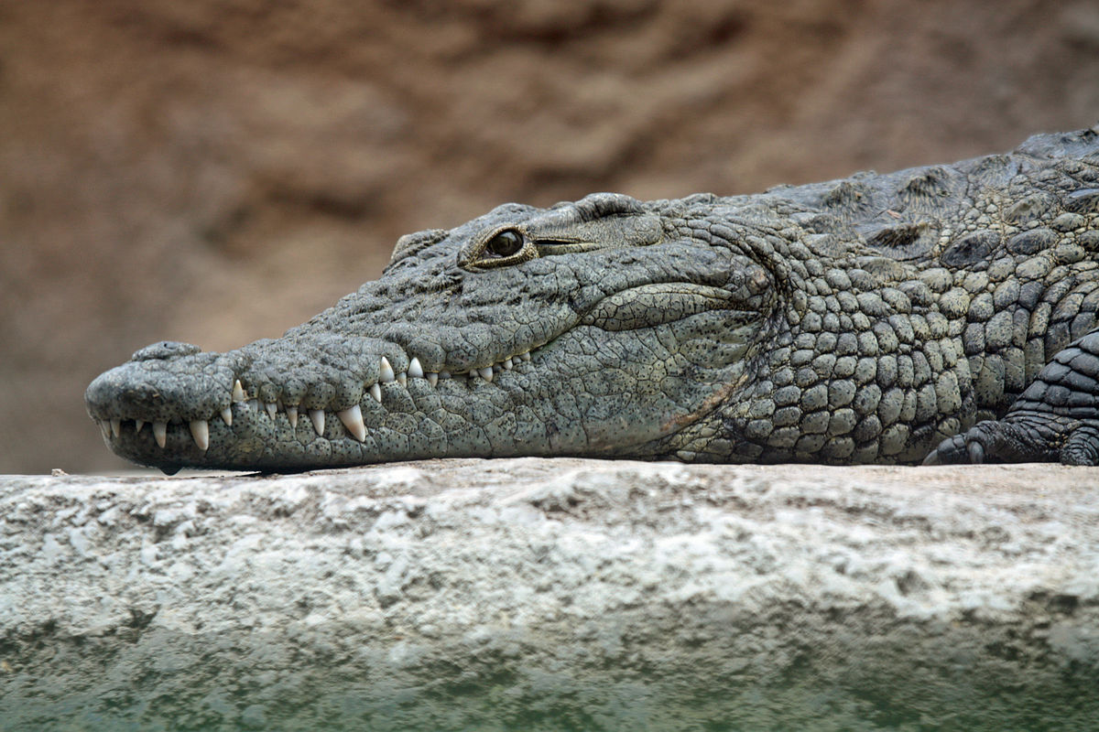

The Zebra:

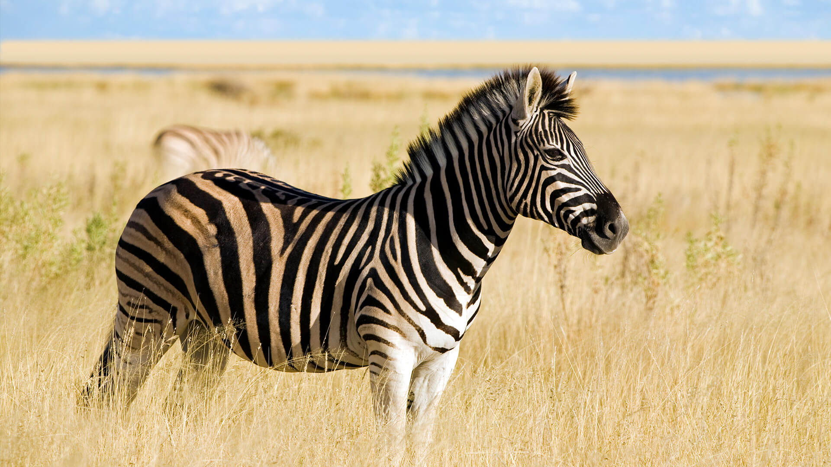

Why the black stripes in the middle of the desert? I know, a little elementary but this guy isn’t blending in here is he? What would a more evolved horse look like? Again, I know a little young, elementary but something to consider when thinking of our growth. If evolution were true and brown with light brown stripes?

The Seahorse:

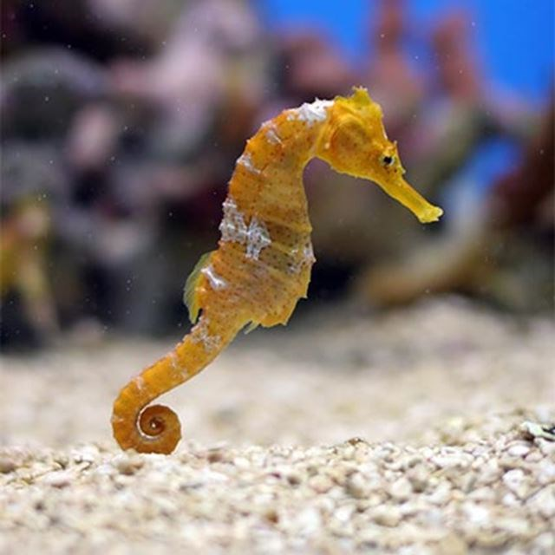

During our many years of education, we at some point learn about Darwin and are taught his theory of evolution and natural selection pointing to the Galapagos Islands as his place of research. Darwin’s states that everything originated from a single celled organism and that all animal life evolved from the very beginning via natural selection. Natural selection states that environmental forces and other external forces shape species from many variations into one instance of a species. So many versions of a horse evolve into what we now see as a horse. What happened to all the other versions? If natural selection were true, animal life would look much different. Tigers wouldn’t have the same stripes, Giraffes would be more stout in order to sprint faster, crocodiles could have longer legs. In addition, instead of one variation of Giraffe, there would be many one offs. Natural selection breaks. This theory has been taught as the truth but is not. There is no real science in it, simply a theory that has stunted our growth and thought with regards to our origins. The truth is that each species of animal was also created. It is reality, everything was created, we were created. Everything on Earth excluding possibly plant life created. No evolution, evolution does not exist, it does not exist.

Again, I believe that none of the animal life, or human life evolved. The images above of different groups of or organizations of people and animal life should be considered as strong as evidence as you need combined with a lot of original thought. Conclusion, nothing originated anything on Earth.

Why aren’t we looking to the stars, the Galaxy, the Universe when thinking of our creation already? I don’t know, it’s careful.

So what do we do with this knowledge? What would the point of our existence if everything was indeed created by Cosmos? I believe they wanted us to create the most beautiful World, with beautiful round and balanced people and beautiful modern and balanced civilizations. I believe Cosmos wanted us to create Utopia on Earth, or many Utopias for each organization of people or group of people in this World. I believe they have given us every resource possible in order to achieve this, however a lot needs to happen and we need to work in unison understanding our purpose. **They did not want us to blow each other up, hurt each other or compete for a superior race, don’t do it, it’s not what we were supposed to do, know it, understand it. We are supposed to round each other out, create blends of people, cultures, food and languages to enjoy.** They, Cosmos wants us to figure out how to foster growth in each culture or organization of people. How to foster progress and equality among people and nations, how to be and how to be happy. We need to create a better, more fair and equal World where everyone has an equal opportunity for happiness and success, **Utopias within Utopia.**

Thank you for reading this short book. I hope that you did what I suggested and separated yourself completely from everyone and everything to allow yourself to critically think. It is be the only way to read this book and the only to come to conclusions on the two most important questions on your own on where we came from and why we are here. This book was not easy to write. I may receive some flack. Regardless, I believe these ideas to be the truth. I hope you enjoyed.

**We were created, created by God, created Cosmos. Our purpose, to create Utopia for them and for us.**

Thank you for reading.

One last thing, if you are stuck on creationism, evolution and believe it or not some even sadly on a superior race, which race is the most advanced? The most modern and elegant looking, the most which may appear from the future …



Shes from China .. .

**Addendum**

Utopia, so how do we get there? How do we create Utopia? I have some ideas but not the answers. First, we need to examine where we are at now and where we want to be, and then create a road map to get closer. What I imagine Utopia to be is a World where there is little to no disparity between income levels. The human race would have a lot more free time. All people in the World would be beautiful and healthy in their own unique way. Finally each individual would have all the resources available at their finger tips to create happiness for him or herself. There would be far more participants in everything from athletics to art, music, theatre… in essence, we would enjoy life much more than we currently do.

Here is how I believe we can get started and get closer to a Utopia:

**First:** Information must flow freely throughout every nook and cranny of the World. Internet access needs to be available everywhere in this World, and it needs to be **free**, thats right free for everyone. Search engines need to continue to be refined and improved to give people access to the most relevant and important information regarding their search for information. **Search results should not be controlled by a human being, ever**. Internet needs to be considered a basic human need, not an additional extravagance in order to make our lives easier. We need this in order to ensure democracy between people. We need this to share ideas, truth and to easily communicate. It is very important that we do this. So very very important. Currently there are companies working on this. Google is one of them, project Loon is a great example.

**Second:** the disparity between low income or no income classes and high income classes needs to be decreased. The World class structure needs to be flattened and evened out. The gap between income levels is too large. We are in a sad state of affairs if really take a look you don’t have to look far to see someone in dire need and even worse in developing nations. Very sad. This can be cured by issuing a base income for everyone regardless of employment. What does this mean? This means, you don’t have to be employed to have an income, an income to at the least house and feed an individual. Low income housing and food stamps especially can be considered slap in the face to a human being. They serve as a reminder to the individual that they are poor and undeserving in this World. It’s not right, we can do better.

People will argue against this. They need to be reminded that we are all products of our environment and that our environment and the people that surround us help us shape our lives. If you are surrounded by beautifu successful people, you will be just as beautiful and successful yourself, it is a fact (Unless of course you mess something up by jeopardizing yourself). Creating a base income and offering education for free will insure that we are making an attempt at leveling the playing field for everyone. Creating a base income will take will take some additional thought of course and **how money is created will have to be revisited**, no more loans!

**Third:** All barriers to entry need to be removed. A “barrier to entry” is something that keeps someone from learning a new skill in order to provide for him or herself. This could be education, this could be resources, tangible or intangible like software or tool belts, this could also be books. If you want to learn a new trade, or skill then all resources including education needs to be readily available. Higher education should be free for everyone as well. What will this do? This will give everyone, regardless of where they are born or who they are born to the same opportunity to create prosperity and happiness for him or herself. It’s unreal, but, there are currently people in this World that are being groomed for success based on their surroundings, appearance or ethnicity, some given everything under the sun in regards to resources and education because of the class of people they are born into. Ever hear of Skull and Bones ? Skull and Bones is a reality. It is unfair, its not right and I believe things need to change a bit.

**Fourth:** We need more time, more time to spend with our families, more time to spend with our friends and loved ones. We need more time to dedicate to our passions, our research, our discovery. We need more time for health, more time for beauty… we need more time. Salaries and wages could be easily adjusted for a shorter work day. There are countries that already practice shorter work days.

**Fifth:** Physical health needs to be a first priority in life. I believe physical health to be paramount for everyone. It is a foundational element I believe towards true happiness and satisfaction in life. Good physical elevates your mood, improves health and gives you better outlook on life.

These are just a few of the things I think as a whole we should make important in order to move forward. Things need to change, and we can start our path to Utopia, we can do this right now.

**Step 1:** Remove two party system, the Republican and Democratic party systems need to go. They currently serve as a way to divide and categorize an entire population. It dumbs us and stunts us. One system, one party, focus on the individual, their beliefs. We could focus on inflating the independent party until the two part system dissolves or until force our leaders to make a radical change.

**Step 2:** Base income for everyone regardless of employment.

**Step 3:** Encourage, foster, promote **Open Source, “free”** **approach** on almost everything. What does this do? It removes barriers to entry for anyone interested in learning anything new or doing something that might help him or her succeed in life. Open source means freely releasing information, formulas, code, “how to’s” on products and services. There are companies already practicing this or trying to encourage this approach to business, Linux based companies, Google and Tesla. Tesla Open Sourced their battery technology. Google offers nearly all of its products and services for free, and Linux is free to download, free to use and the Linux community encourages participation.

Do something for me, try to devise of an alphabet on your own. Create the alphabet without knowing what an alphabet is, or better yet attempt to try to create a language from the beginning… ....

If a singular God created the human race, then I believe he would have only created only one organization of people and the people would appear nearly the same, and more cohesive groups with differences being minimal would exist, there would be no race issues. Why would he create many organizations of people? He wouldn’t.

Have you heard of Deism? Many of our early leaders and founding fathers followed this belief system. John Quincy Adams, Ethan Allen, Benjamin Franklin, Thomas Jefferson, James Madison, Thomas Paine, and George Washington all followed this belief system. Thomas Jefferson actually went a step further and wrote a bible. His bible allows you to focus on what is important, God.

Buddhism is good too!

I love Catholicism without Jesus.

All religions were created by man, man is flawed.

**ඔබට ස්තුතියි!**

This is “Thank you!” in Sinhala, language of Sri Lanka. It is probably the most inter-planetary language of all.

ඔවුන් අප අතර ජීවත් වෙති